EVENT REPORT

FITNESS & WELLNESS CLUB – EVENT REPORT -2025-2026

✨ EVENT TITLE: “MOVE • GLOW • GROW” ✨

A Celebration of Fitness, Health & Happiness!
- Date: ____________
- Venue: ____________
- Time: ____________
- Organized by: Fitness & Wellness Club

EVENT OVERVIEW
The Fitness & Wellness Club successfully organized an energetic and inspiring wellness event, “Move • Glow • Grow” 🌟. The event was designed to encourage students to adopt a healthy lifestyle by balancing physical fitness 🏋️, mental wellness 🧘, healthy habits 🥗, and positive thinking
The atmosphere was filled with energy, enthusiasm, smiles, and motivation 😄🔥. Students actively participated in various activities and discovered that fitness is not only about exercising—it is also about feeling strong, confident, peaceful, and happy from within.

EVENT HIGHLIGHTS
- Energetic Fitness Session
The event began with an exciting warm-up and fitness session 🎶💪. Participants performed stretching exercises, simple workouts, and fun physical activities. The session helped everyone understand the importance of keeping the body active and flexible.
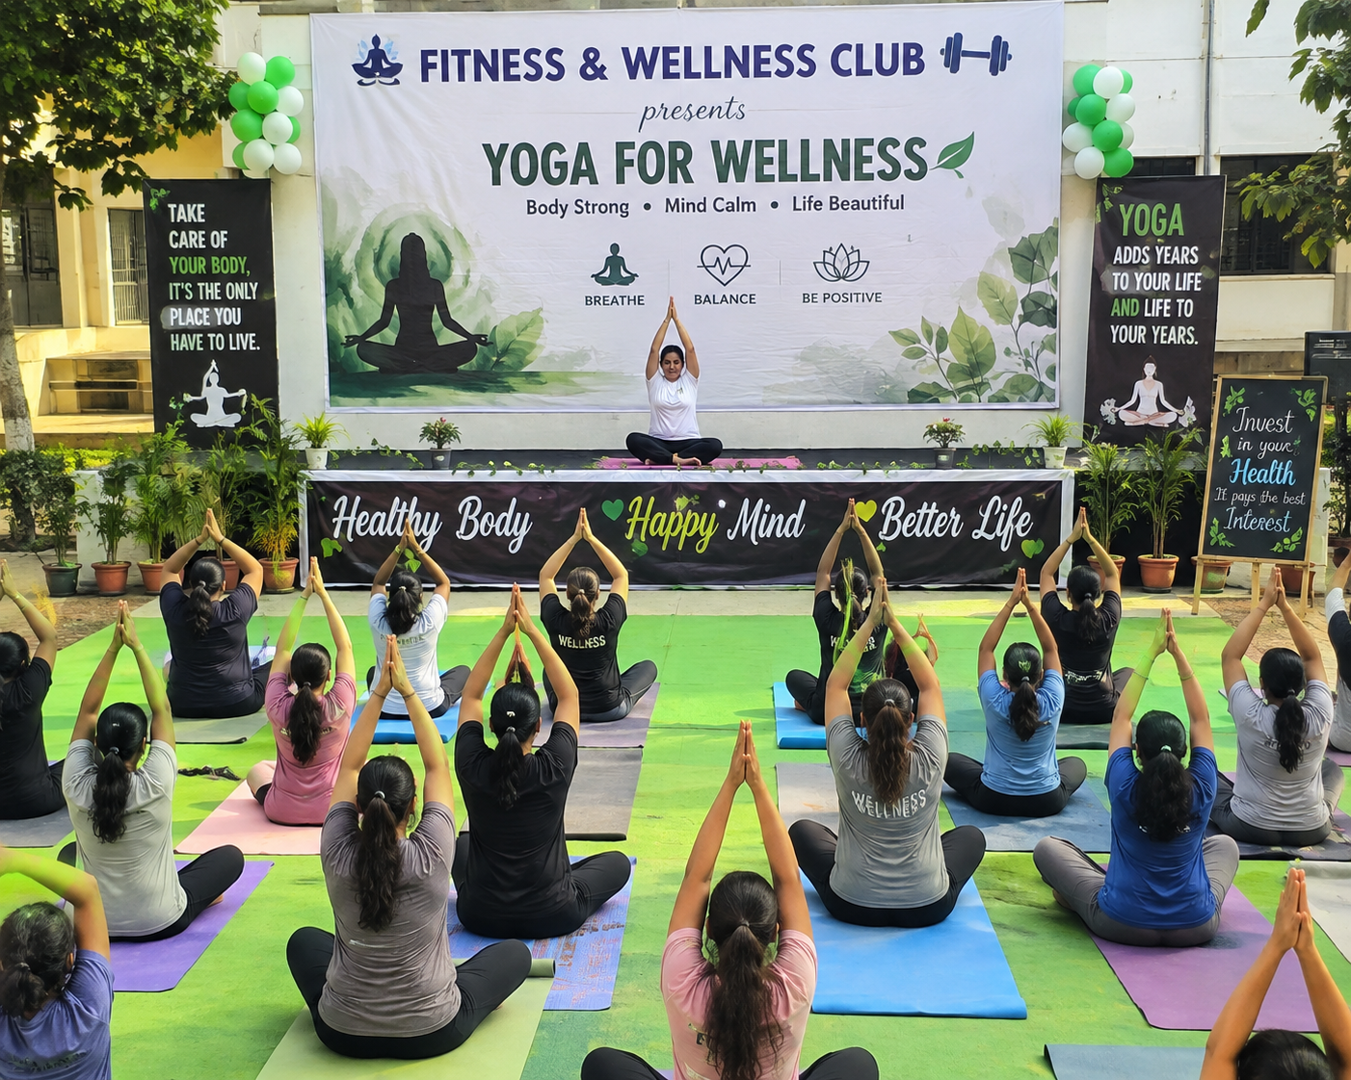
- 2. Yoga & Mindfulness Moment
A peaceful yoga and breathing session was conducted to promote relaxation and mental balance. 🌿✨ Participants learned how a few minutes of mindfulness can help improve concentration, reduce stress, and create a calm mindset.
- 3. Healthy Lifestyle Awareness
An interactive session was conducted on the importance of nutritious food and healthy daily habits. 🍓🥦🥛 Students were encouraged to make small but meaningful choices for a healthier lifestyle.
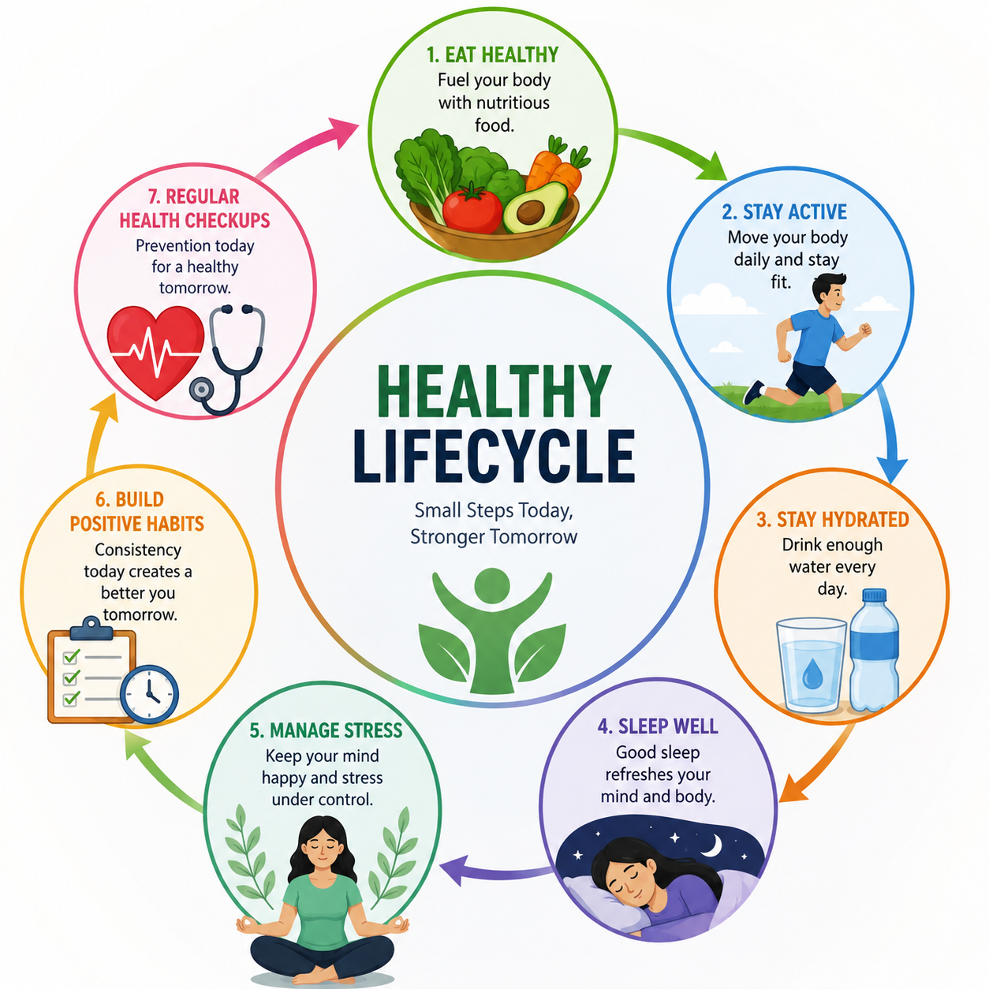
🌱 “Healthy habits may begin small, but they create a stronger future.”

4. Fun Fitness Challenges
The event became even more exciting with enjoyable fitness challenges and team activities! Participants showed great teamwork, confidence, determination, and sportsmanship.

PARTICIPANT EXPERIENCE
The event received an enthusiastic response from students. 👏🎉 Participants actively engaged in every activity and appreciated the positive and motivating environment.
The programme created a beautiful message among everyone:

💫 “Fitness is not a destination… it is a lifestyle!” 💫
Students left the event feeling refreshed 🌸, energized ⚡, motivated 🔥, and inspired 🌟 to take better care of both their physical and mental well-being.

📸✨ MEMORABLE MOMENTS
🎉 Smiling faces and energetic participation
💪 Powerful workout sessions
🧘 Peaceful moments of yoga and relaxation
🤝 Teamwork and friendship
🏆 Fun challenges and achievements
📸 Beautiful memories captured together

🌈 Every activity became a memory, and every participant became a part of our wellness journey! 💚

OUTCOME OF THE EVENT
The Fitness & Wellness Club event successfully promoted:
✨ Healthy lifestyle awareness
Physical fitness and strength
Mental wellness and mindfulness
Team spirit and social interaction
Positive daily habits
Motivation and self-confidence
The event proved that wellness is a combination of a healthy body, peaceful mind, and positive attitude. 🌸

CONCLUSION

The “Move • Glow • Grow” Fitness & Wellness Event was a wonderful success filled with energy, learning, positivity, and happiness. 🎊💪🧘‍♀️
The Fitness & Wellness Club remains committed to inspiring students to make health and wellness a meaningful part of their everyday lives. 🌿

LET'S KEEP MOVING!

LET'S KEEP GROWING!

✨ LET'S KEEP GLOWING!

FIT BODY • CALM MIND • HAPPY LIFE ✨
“Together, we don't just build stronger bodies—we build healthier and happier lives!”

